Welbeck Road Health Centre  Welbeck Road Health Centre, 1b Welbeck Road, Bolsover, Chesterfield, Derbyshire, S44 6DF  01246 823742 | 

Name:
Date of Birth:
Address:
NHS Number (if known):

Asthma Review

Please complete the following questions to allow your health care professional to assess your Asthma.

This questionnaire is for a routine review of your symptoms.
If you are experiencing severe shortness of breath at present, please follow your care plan (if you have one) or ring your GP, or 999 immediately.

Your Asthma

1. How often does your asthma cause symptoms during the day?
Never
1 to 2 times per month
1 to 2 times per week
Most days

2. How often does your asthma cause symptoms at night?
Never
1 to 2 times per month
1 to 2 times per week
Most nights

3. How often does your asthma limit your activities
Never
1 to 2 times per month
1 to 2 times per week
Most days

4. How many asthma exacerbations have you had in the past year? An ‘exacerbation’ means either an asthma attack or a sudden worsening in your asthma where you needed to increase your inhalers. You may also have needed steroid tablets, nebulisers and/or antibiotics.

5. How many times have you attended Accident and Emergency Department since your last asthma review?

6. What triggers your asthma?
Airborne dust Perfume
Animals Pollen
Cold air Respiratory infection
Damp Seasonal
Dust mites Tobacco smoke
Emotion Warm air
Exercise Wind
Humidity No triggers identified

Inhaler Technique

It is essential to have a good inhaler technique to ensure that your medication gets to the part of your lungs that need it. Please watch the specific inhaler video below to check that you are using your inhalers correctly:

For further information, see: https://www.asthma.org.uk/advice/inhaler-videos/

1. I have watched the above relevant inhaler technique videos and am happy with my inhaler technique
Yes
No

Your Lifestyle – Alcohol

Please answer the following questions which are validated as screening tools for alcohol use:

AUDIT–C QUESTIONS | Scoring System |  |  |  |  | Your Score
AUDIT–C QUESTIONS | 0 | 1 | 2 | 3 | 4 | Your Score
How often do you have a drink containing alcohol? | Never | Monthly or Less | 2-4 times per month | 2-3 times per week | 4+ times per week
How many units of alcohol do you drink on a typical day when you are drinking? | 1-2 | 3-4 | 5-6 | 7-9 | 10+
How often have you had 6 or more units if female, or 8 or more if male, on a single occasion in the last year? | Never | Less than monthly | Monthly | Weekly | Daily or almost daily
A score of less than 5 indicates lower risk drinking |  |  |  |  | TOTAL:

Scores of 5 or more requires the following 7 questions to be completed:

AUDIT QUESTIONS  (after completing 3 AUDIT-C questions above) | Scoring System |  |  |  |  |  | Your Score
 | 0 | 1 | 2 | 3 |  | 4 | Your Score
How often during the last year have you found that you were not able to stop drinking once you had started? | Never | Less than monthly | Monthly | Weekly |  | Daily or almost daily
How often during the last year have you failed to do what was normally expected from you because of your drinking? | Never | Less than monthly | Monthly | Weekly |  | Daily or almost daily
How often during the last year have you needed an alcoholic drink in the morning to get yourself going after a heavy drinking session? | Never | Less than monthly | Monthly | Weekly |  | Daily or almost daily
How often during the last year have you had a feeling of guilt or remorse after drinking? | Never | Less than monthly | Monthly | Weekly |  | Daily or almost daily
How often during the last year have you been unable to remember what happened the night before because you had been drinking? | Never | Less than monthly | Monthly | Weekly |  | Daily or almost daily
Have you or somebody else been injured as a result of your drinking? | No |  | Yes, but not in last year |  |  | Yes, during last year
Has a relative or friend, doctor or other health worker been concerned about your drinking or suggested that you cut down? | No |  | Yes, but not in last year |  |  | Yes, during last year
 |  |  |  |  | TOTAL:
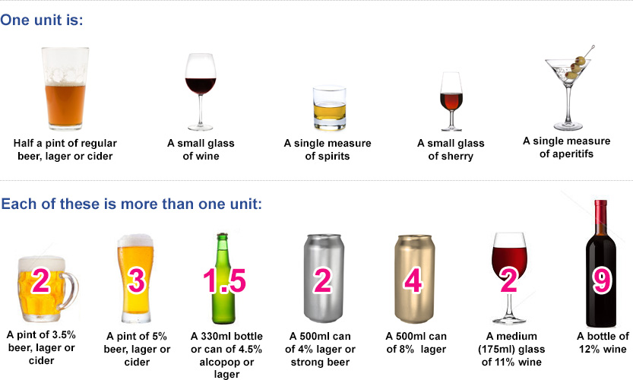

Your Lifestyle – Smoking

Do you smoke? | Never  smoked | Ex-smoker | Yes
Do you use an e-Cigarette? | No | Ex-User | Yes
How many cigarettes did/do you smoke a day? | Less than one | 1-9  10-19 | 20-39  40+
Would you like help to quit smoking? | Yes | No
 | For further information, please see: www.nhs.uk/smokefree

Asthma Control Test Score

The Asthma Control Test provides a score to help you and your healthcare provider determine if your asthma symptoms are well controlled.
If you are 12 years or older, please complete the questions below.

1. How often did your asthma prevent you from getting as much done at work/school/home?
All the time
Most of the time
Some of the time
A little of the time
None of the time

2. How often have you had shortness of breath?
More than once a day
Once a day
3-6 times a week
1-2 times a week
None at all

3. How often did your asthma symptoms wake you up at night or early in the morning?
4 of more times a week
2-3 nights a week
Once a week
Once or twice
Not at all

4. How often have you used your reliever inhaler (usually blue)?
3 or more times a day
1-2 times a day
2-3 times a week
Once a week or less
Not at all

5. How would you rate your asthma control?
Not controlled
Poorly controlled
Somewhat controlled
Well controlled
Completely controlled

Further Questions

- Do you have a written asthma care plan?
No
Yes and I am happy with it
Yes but I am not happy with it
Yes but I have lost it
- I have the following information, questions, or concerns that I would like to raise with my Asthma Nurse or Doctor:

Please see the following links for further information on Asthma that you may find useful:

NHS Choices - http://www.nhs.uk/conditions/asthma/Pages/Introduction.aspx
Patient. Info - http://patient.info/health/asthma-leaflet
Asthma UK - https://www.asthma.org.uk

Follow-Up

When you are happy with all your above answers, please return this questionnaire to your GP practice.

Depending upon your answers and your other medical conditions, you will be contacted if you need to be seen in clinic for a further assessment.
Should your symptoms change, please seek medical advice, and book an appointment if required.

