Clinical Commissioning Group
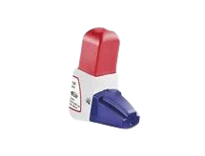
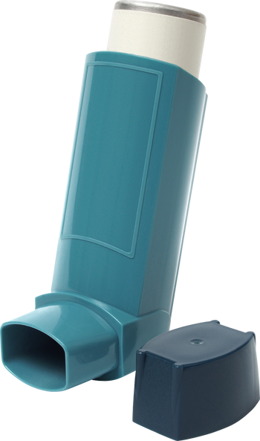
Be Greener and Breathe Better

A Patients Guide to Green Inhalers

Going 'Greener'
Everyone is talking about 'going greener', 'reducing my carbon footprint' and 'harmful carbon dioxide'. But what does this mean for me and my health? How can I make a difference and make sure that I stay well?
Our Carbon Footprint
The amount of greenhouse gases released by a place or person is known as its 'carbon footprint'. The NHS is responsible for 5% of the UK's total carbon footprint. To help combat climate change, the NHS has made a commitment to reduce its carbon footprint to net zero by 2040.
How are inhalers linked to climate change?
In England, more than 65 million inhalers are prescribed every year, and about 70% of these are pressurized metered dose inhalers (MDIs). MDIs have a much higher carbon footprint than other types of inhalers, such as Dry Powder Inhalers (DPIs) and Soft Mist Inhalers (SMIs) This is because MDIs contain propellants which are very strong greenhouse gases, thousands of times more powerful than carbon dioxide. Inhalers contribute 3-4% of the entire NHS carbon footprint. DPIs and SMIs have a much lower carbon footprint and will be suitable and work well for most patients.
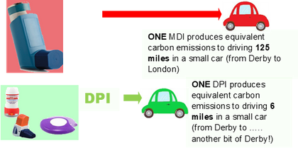

What can I do to help?
Make sure your breathing is as good as it can be by:
- Keep up to date with any recommended vaccinations such as COVID-19, Flu and Pneumonia.
- If you smoke, try to stop – ask your GP or nurse about smoking cessation services. Attend your GP practice for your asthma or COPD reviews when invited.
- Whilst having your review ask your healthcare team to check how you are using your inhaler.
- If you have asthma contact your GP practice if you are needing to use your reliever (blue) inhaler three times or more each week.
- If you are using an MDI it is most effective if used with a spacer. Your spacer should be replaced every year.
- A spacer should also be hand washed once a week and left to air dry – not dried with a tea towel. For further information about your spacer see the Asthma+Lung UK website: https://www.asthma.org.uk/advice/inhalersmedicines-treatments/inhalers-and-spacers/spacers/
- After using a steroid inhaler, it is important to rinse your mouth (then spit out the water) or brush your teeth. This will help stop your mouth becoming sore.
- Reduce waste - don't order more inhalers than you need
Should I switch to a Dry Powder (DPI) or Soft Mist Inhaler (SMI)?
The 'greenest' inhaler is the one that you can use easily and correctly, and which controls your asthma or COPD well. DPIs aren't suitable for everyone.
If you do need an inhaler containing greenhouse gases, please do not feel guilty. If you need an MDI, it may still be possible to switch to an inhaler with a lower carbon footprint – please ask your GP, nurse, or pharmacist for advice.
But many patients may find a DPI is easier to use:
- DPIs do not rely on hydrofluorocarbon propellants to spray medication into your lungs; therefore, their carbon footprint is typically 20 times lower than an MDI (a huge reduction!)
- DPIs require less co-ordination, and may be easier to use, as the dose can be prepared before breathing in through the inhaler.
- DPIs all come with a dose counter, so you know when to reorder
- DPI's are NOT suitable if you have an allergy/anaphylaxis to lactose (or milk protein)
What is the best way to dispose of an empty inhaler?
Do not throw used or unwanted inhalers in the bin. Return them to the pharmacy. Pharmacies can send inhalers for incineration or recycling, both of which are better than sending them for landfill. Don’t put your inhaler in kerb side recycling as it won’t be recycled. If all used inhalers in the UK were returned for safe disposal, this could save 512,330 tonnes of CO2eq annually - the same as a VW Golf car being driven around the world 88,606 times!
Talk to your practice nurse, doctor or pharmacist for more information. BGBB V3. Issued May 2022 Review by May 2025

